Rear Admiral Nathan A. Moore

Assistant Commandant for Engineering & Logistics (CG-4)

U.S. Coast Guard
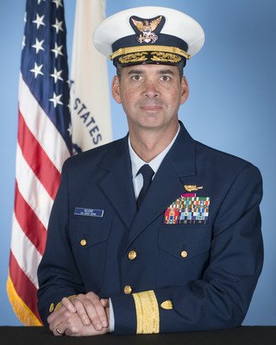
Rear Admiral Moore reported for duty as Deputy Commader, Pacific Area following assignment as the Chief of Staff. Previous to that from 2015-2017, he was commanding officer of USCGC STRATTON, where the ship's primary missions included Law Enforcement (Counter Narcotics and Living Marine Resources), Search and Rescue, and Defense. Rear Admiral Moore was born in Ohio and raised in Gadsden, Alabama. He graduated from the United States Coast Guard Academy with a Bachelor of Science degree in Naval Architecture and Marine Engineering and was commissioned in May 1992.
His first assignment was as an Engineer Officer in Training (EOIT) and Damage Control Assistant (DCA) onboard USCGC POLAR STAR (WAGB-10) in Seattle, WA. From 1994–1996, Rear Admiral Moore was a ship stability instructor at the Navy Surface Warfare Officer School in Newport, Rhode Island. From 1996–1998, he attended the University of Michigan where he earned both a Master of Science in Naval Architecture and Marine Engineering and a Master of Business Administration.

His subsequent assignment was as the Engineer Officer onboard USCGC HARRIET LANE (WMEC 903) in Portsmouth, Virginia. In 2001, Rear Admiral Moore reported to the Coast Guard Personnel Command Center in Washington, DC where he served as Chief of the Officer Promotion Boards Section. From 2004-2006 Rear Admiral Moore served as the Executive Officer of the USCGC VENTUROUS (WMEC 625) in St. Petersburg, Florida. From 2006-2008 Rear Admiral Moore was the Commanding Officer of Naval Engineering Support Unit Honolulu, Hawaii. He then served as Commanding Officer of USCGC RESOLUTE (WMEC 620) in St. Petersburg, Florida from 2008-2010. From 2010-2012 he served as the Chief of the Officer Assignment Branch (OPM-2) at the Personnel Services Center in Arlington, Virginia. Following completion of a year of Senior Service School at the Eisenhower School earning a master’s degree in National Resource Strategy, he then served from 2013-2015 as the Chief, Office of Naval Engineering at Coast Guard Headquarters.
Rear Admiral Moore’s personal awards include two Legions of Merit, four Meritorious Service Medals, two Coast Guard Commendation Medals, and the Navy Commendation Medal. He has been a registered Professional Engineer in the state of Michigan since 1999.

