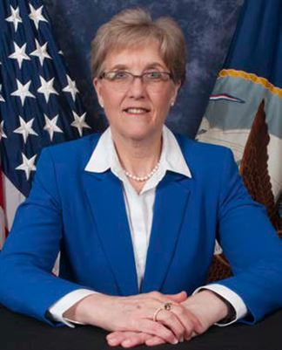
Stephanie Douglas
Deputy Commander, Logistics, Maintenance and Industrial Operations, Naval Sea Systems Command
Ms. Douglas was selected for appointment to the Senior Executive Service in April 2016. She has six years of experience as a civil servant while serving as Deputy Director for Fleet Maintenance (N43B) at U.S. Fleet Forces Command. She was responsible for fleet maintenance policy and a $3.5B fleet maintenance budget supporting two Naval Shipyards, three Regional Maintenance Centers, and Trident Refit Facility (TRF), Kings Bay and Readiness Support Group, New London to deliver mission ready ships to combatant commanders and achieve expected service life. Most recently she served as the Executive Director for Navy Regional Maintenance Center (NRMC) in Norfolk, Va. Her duties include oversight of the operations and management of the Regional Maintenance Centers in the execution of private-sector, depot- level maintenance and modernization, surface ship intermediate-level maintenance, and fleet technical and engineering support world-wide.
Ms. Douglas assumed her present duties as Deputy Commander, Logistics, Maintenance and Industrial Operations, Naval Sea Systems Command in August 2019.
Ms. Douglas previously served as a naval officer from 1981 to 2010, retiring in the grade of Captain with 29 years of service. During her active duty career as an Engineering Duty Officer, she served on USS Emory S Land (AS 39) as Electrical Repair Officer and at numerous maintenance activities. Her tours included Charleston Naval Shipyard (CNSY) as nuclear and non-nuclear ship superintendent for submarines; Portsmouth Naval Shipyard (PNSY) as Baseline Advanced Industrial Management (BAIM) Implementation Manager and Operations Planning Manager; Supervisor of Shipbuilding Conversion and Repair, Portsmouth (now a portion Of Mid-Atlantic Regional Maintenance Center), as Planning Officer; and Pearl Harbor Naval Shipyard and Intermediate Maintenance Facility (PHNSY& IMF) as Production Resources Officer. During this tour, she led the damage removal efforts in Guam for USS San Francisco (SSN 711) following the ship’s collision. She served two tours at Ship Repair Facility and Japan Regional Maintenance Center, Japan, first as Production Officer and Executive Officer and, finally, as Commanding Officer, where she made all preparations for the arrival of USS George Washington (CVN 73), the first nuclear powered warship to be home ported overseas and successfully completed CVN 73’s first Forward Deployed Naval Forces availability. Her staff assignments include Commander, Navy Surface Forces, Atlantic as the Surface Type Desk Coordinator for amphibious, auxiliary, mine warfare and command ships, Naval Sea Systems Command (NAVSEA 04) as the Deputy Director of the Shipyard Management Group, where she developed corporate policy and oversaw business operations for four naval shipyards. Her final Updated 4-16 active duty tour was as Surface Ship Program Director in the Fleet Maintenance Directorate (N43) on the staff of U.S. Fleet Forces Command.
Ms. Douglas graduated from Auburn University where she earned a Bachelor of Science Degree in Chemical Engineering and her commission from the NROTC program in 1981. She earned a Naval Engineers Degree, a Master of Science Degree in Mechanical Engineering and a Master of Science Degree in Ocean Systems Management from Massachusetts Institute of Technology (MIT) in 1992.
Ms. Douglas’ military decorations include the Legion of Merit, Meritorious Service Medal with a Silver Star, Navy Commendation Medal and two Meritorious Unit Commendations. Ms. Douglas has been an active member of American Society of Naval Engineers (ASNE) since 1987, and has served as Secretary, Vice Chair and Chairperson of the Tidewater ASNE Section and as National Councilor.

