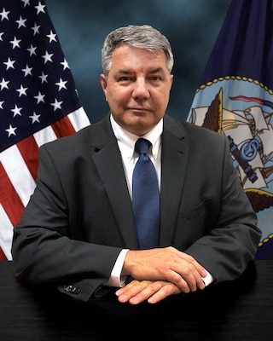

Mr. Michael Haycock

Deputy Commander, Navy Regional Maintenance Center and Executive Director, Surface Ship Maintenance and Modernization

Mr. Michael Haycock currently serves as the Deputy Commander for Navy Regional Maintenance Center (CNRMC) and Executive Director of Surface Ship Maintenance and Modernization (SEA 21B) at Naval Sea Systems Command (NAVSEA). He oversees the operations and management of the Regional Maintenance Centers in the execution of private-sector, depot- level maintenance and modernization, surface ship intermediate-level maintenance, and fleet technical and engineering support world-wide. Additionally, he provides executive leadership to the programs responsible for the life-cycle management of the Navy’s in-service surface ships, including critical modernization and maintenance efforts, as well as Foreign Military Sales, training, and ship inactivation.
Mr. Haycock was selected for appointment to the Senior Executive Service (SES) in June 2020, and has been in federal service for over 35 years, serving in a variety of key leadership positions. As one of the U.S. Coast Guard’s (USCG) senior most officers, Mr. Haycock served as Assistant Commandant for Acquisition and Chief Acquisition Officer (CAO), directing efforts across all Coast Guard acquisition programs, acquisition support, personnel, finance, excess defense article and foreign military sales and research and development activities to execute the service’s acquisition portfolio. Prior to reporting as CAO, he served as Program Executive Officer and Director of Acquisition Programs, where his duties included management oversight of all Coast Guard acquisition programs and projects for the modernization and recapitalization of surface, air, command and control, and logistics assets.
Before leading acquisition efforts, he served as the Coast Guard’s Assistant Commandant for Engineering and Logistics, and Chief Engineer. In that role, he oversaw all naval, civil, aeronautical, and industrial engineering and logistics for the Coast Guard’s 23,000 facilities, 230 ships, 1,800 boats and 200 aircraft. Additional ashore tours include assignments as the Commander of the Surface Forces Logistics Center, Surface Domain Deputy Project Manager, the National Security Cutter Project Manager, Icebreaker Support Section Assistant at the Maintenance and Logistics Command Pacific, Project Manager for the Polar Console Renewal Project at Naval Engineering Support Unit Seattle, and Commanding Officer of the Naval Engineering Support Unit Honolulu.
With over 11 years of sea service, Mr. Haycock’s sea tours include assignments as Damage Control Assistant aboard USCGC Polar Star (WAGB-10), Assistant Engineer Officer aboard USCGC Boutwell (WHEC-719), Engineer Officer aboard cutters Mellon (WHEC-717), and Polar Sea (WAGB-11) and as Executive Officer and later Commanding Officer of USCGC Sherman (WHEC 720).
He is a native of Delavan, Illinois, and graduated from the USCG Academy in 1985 with a Bachelor of Science degree in Electrical and Electronics Engineering. He later earned a Master of Science Degree in Naval Architecture and Marine Engineering and a Master of Science Degree in Industrial and Operations Engineering from the University of Michigan in 1992. His military awards include the Coast Guard’s Distinguished Service Medal, Legion of Merit, Meritorious Service Medal with Operational Device, Coast Guard Commendation Medal with Operational Device, Coast Guard Achievement Medal, Antarctica Service Medals, Arctic Service Medal and several other unit and service awards.

