Rear Admiral James Downey

Program Executive Officer for Aircraft Carriers

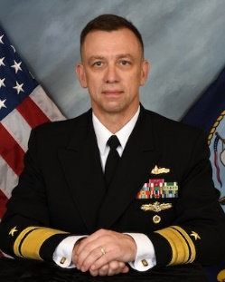
Rear Adm. James Downey is a native of New York. He is a 1986 graduate of the State University of New York, Albany, New York with a Bachelor of Science in Economics and Computer Science. He was commissioned in 1987 and is a 1997 graduate of the Naval Postgraduate School, Monterey, California with a Master of Science in Computer Science followed by Engineering Duty Officer (EDO) School in Port Hueneme, California, where he graduated with distinction and received the Founder’s Award.
He qualified as a surface warfare officer aboard USS Hayler (DD 997) in 1989. Additional operational assignments include intelligence briefing officer to the Commander in Chief, Combined Forces Command, U.S. Forces Korea , Seoul, Korea; and multiple deployments afloat in the North Atlantic, Baltic, Arctic Circle, and Pacific.
Engineering duty officer assignments include assistant program manager for surface and subsurface integration for GPS and Navigation Sensor System Interface programs, leading Tomahawk integration; chief engineer for high assurance systems at the Defense Information Systems Agency and National Security Agency; officer in charge of Space and Naval Warfare Systems Command , Yokosuka, Japan; CVN 21 program chief engineer, principal assistant program manager , and warfare systems director; CG(X) major program manager; and major program manager for the DDG 1000 program including delivery of the first ship of the class.
His first flag assignment was commander, Navy Regional Maintenance Center during which time he also served as Naval Sea Systems Command’s deputy commander for surface warfare. He assumed duties as program executive officer, Aircraft Carriers in June 2019.
Downey’s awards include the Legion of Merit (two awards), the Defense Meritorious Service Medal (two awards), the Meritorious Service Medal (two awards), and various other personal, unit, and service awards.

